TRANSCUTANEOUS PACEMAKER

Introduction:

The American Heart Association Advanced Cardiac Life Support (AHA ACLS) guidelines recommend TCP as a temporizing measure for symptomatic bradycardia and as a consideration for asystole.

Application
- Application of the external pacemaker is simple.
- Electrodes/pads and monitor leads, if necessary, are placed on the patient.
- About 2-3 cm of space should be left if separate defibrillation pads are required, and the second pad should be placed posteriorly, just below the left scapula.
- The desired heart rate is chosen and the current is set to zero milliamperes (mA).
- The TCP is then turned on and the current is increased as tolerated until capture is achieved.

Pulse duration
Pulse duration is the time of impulse stimulation.
Current TCPs deliver 40 (Zoll) or 20 (all others) msec pulses.
Current
- Average current necessary for external pacing is about 65-100 mA in unstable bradycardias and about 50-70 mA in hemodynamically stable patients and volunteers.
- At this current, more than 90% of patients tolerated pacing for 15 or more minutes.
- Using longer pulse duration and larger electrodes permits patients to tolerate higher applied current.
- One hundred milliamperes of current applied over an average (50-ohm resistance) chest for 20 msec will deliver 0.1 Joules.
- This is well below the 1-2 Joules required to cause an uncomfortable tingling sensation in the skin. The force of skeletal muscle contraction, not the electric current, determines TCP discomfort.
- Current TCPs are capable of delivering up to 140-200 mA tolerably.
Electrodes
- Pain is a function of the current delivered per unit of area.
- Electrodes with a surface area of at least 5 cm².
- Minimize pain sensation.
- The amount of pain for a current of a given strength reaches a plateau once the electrode surface area exceeds 10 cm².
- Most commercially available electrodes are 80-100 cm².
ECG electrodes
- ECG signal quality is important during demand pacing for accurate sensing as well as interpretation of pacing results.
- It is important to place the ECG electrodes as far away from the pacing electrodes as possible in order to obtain a clear ECG signal.
Pacing Electrodes
- Manufacturer recommendations for placement of pacing electrodes and cables should be followed. Do not reverse the recommended placement for the pacing electrodes and pacing cable.
- If the electrodes or cables are reversed, failure to capture or extremely high capture thresholds may result.

PACING ELECTRODE PLACEMENT

- ANTERIOR –POSTERIOR
- ANTERIOR –LATERAL

ANTERIOR –POSTERIOR:

- Most common pacing electrode placement is anterior -posterior.
- Anterior electrode is placed on the left anterior chest, halfway between the xiphoid process and left nipple at the apex of the heart.
- The posterior electrode is placed on the left posterior chest beneath the scapula and lateral to the spine at the heart level.

ANTERIOR –LATERAL:
- Anterior-lateral (sternum-apex or anterior-apex) placement may also be used for pacing.
- The lateral (apex) electrode is placed on the left anterior torso, just lateral to the left nipple in the mid axillary line.
- The anterior electrode is placed in the right subclavicular area lateral to the sternum.
- Same placement as for defibrillation.

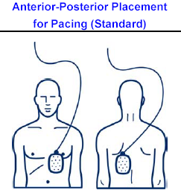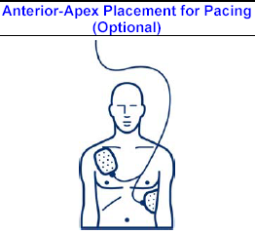

Monitor
It is used for determination of electrical capture and pulse generation can be difficult when skeletal muscle is stimulated.
Synchronous/asynchronous modes
- In the fixed rate (asynchronous) mode, the TCP delivers an electrical stimulus at preset intervals, independent of intrinsic cardiac activity.
- In theory, this could induce arrhythmias if stimulation occurs during the vulnerable period.
- Most current models have fixed rate and synchronous pacing.
- Synchronous pacing is a demand mode in which the pacer fires only when no complex is sensed for a predetermined amount of time.
- Pacing generally should be started in the synchronous mode
- Demand (synchronous) Mode is the preferred means of pacing as it paces only when the patient's heart rate falls below a level set by the clinician.
- This avoids problems such as a pacer impulse landing on a T-wave and possibly causing a ventricular dysrhythmia.

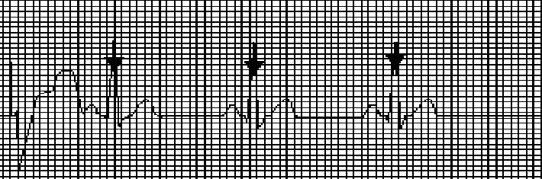
Demand pacing delivers impulse only when needed pacemaker is inhibited when patients intrinsic rate is higher than set pace rate.

Fixed (asynchronous) Mode paces at the rate set by the clinician regardless of the patient's heart rate.
This mode is not the preferred means of pacing and is usually reserved for when 1) the pacer cannot sense the heart rate or 2) when motion artifact prevents the pacer from sensing the heart rate.

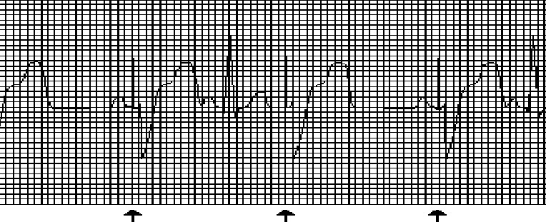
Pace maker delivers current at selected rate and ignores intrinsic rate
The non-demand pace mode delivers electrical stimuli at the selected pace rate regardless of the patient’s intrinsic cardiac activity.
This mode of pacing may be used when inhibition of a pacemaker occurs due to sensing of signals other than R waves, such as muscle artifact, or P or T waves (over sensing) and other troubleshooting measures are unsuccessful.
Although the pace stimulus may fall on a T wave, it appears the risk of inducing ventricular tachycardia or ventricular fibrillation is more a theoretical than an actual risk.
Indications:

1. Slow heart rates (bradycardias) that produce unstable hemodynamics (e.g. low BP, stroke volume, SvO2).
2. Slow heart rates (particularly escape rhythms) that do not respond to drug therapy.
3. Any condition as a temporary measure in preparation for a transvenous pacemaker.
4. Non emergent indications.
a. Overdrive pacing (when drugs and electrical cardio version have failed).
b. Heart blocks in the presence of myocardial infarction.

Patient Preparation:

- Psychological Educate patient about possible discomfort with pacing.
- Instruct patient and family that muscles will twitch with each pacemaker beat.
- Sedation If sedation is needed (a normal occurrence), be prepared to initiate when pacemaker is activated.
- Discomfort may not be noticed until higher mAs are used.
- Sedation should be for a targeted lev(e.g. Ramsey of 2-4).
- Skin Prepare skin for pad placement (cleaning, shaving if necessary). Be sure to avoid breaking the skin while shaving.
- Check skin routinely to avoid severe skin irritation.
- Move pad placement (if patient condition allows) as necessary to protect skin.

Pacing procedure:
Overall, the pacing system is simple. An ECG monitor, ECG electrodes and cable are needed to display the ECG and monitor the response to pacing therapy.
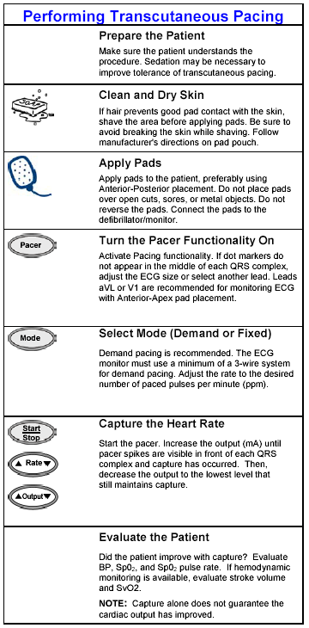

Selecting Mode, Rate, and Current:
- Pacing current should remain at zero mill amperes (mA) until the pacing mode has been selected. Ensure EKG electrodes are in place, as well as pacing electrodes.
- Current may then be adjusted upward until capture is identified.
- In conscious patients increase the current slowly while assessing for capture
- Increase the current by 20 mA steps until mechanical capture.
- Then decrease current by 5 mA steps in achieve lowest current that will maintain mechanical capture. Set rate at 70 PPM initially (unless directed otherwise by medical control).

Assessing for Capture:

Electrical capture

Occurs when a pacing stimulus leads to depolarization of the ventricles and is confirmed by ECG changes displayed on the monitor.

A widening of the QRS complex usually represents it and a tall, broad T wave, which is typical of a complex originating in the ventricle.
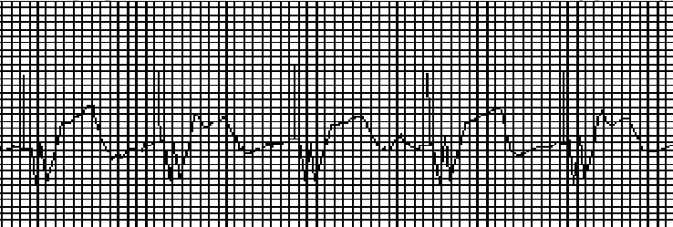
Continuous electrical capture
Mechanical Capture:
Mechanical capture of the ventricles is evidenced by signs of improved cardiac output, including a palpable pulse, rise in blood pressure, improved level of consciousness, improved skin color and temperature.
Both electrical and mechanical capture must occur to benefit the patient.

Intermittent capture:
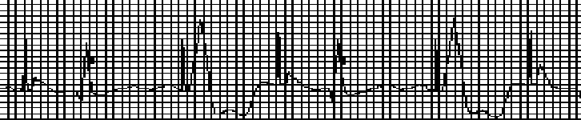
Second and fourth pacing stimuli results in capture. Current should be increased until continuous capture occurs

Sensed and paced beats:
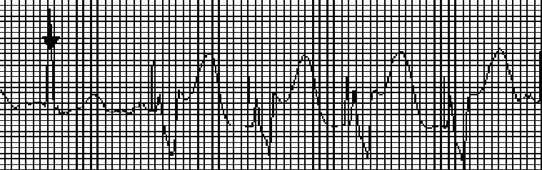
Sensed intrinsic beat followed by continuous electrical capture
Under Sensing:
Under sensing occurs when the pacemaker does not sense intrinsic activity, and delivers a pace pulse (current). 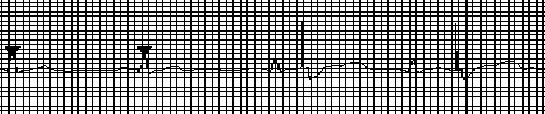
First two QRS Complexes are sensed. Remaining QRS Complexes are not of sufficient amplitude to be detected. Pace maker’s fires even though patients intrinsic rate is above the set pace rate.

Over Sensing:
Over sensing is inappropriate inhibition of a demand pacemaker due to detection of signals other than R waves, such as muscle artifact or T waves. Over sensing is inappropriate inhibition of a demand pacemaker due to detection of signals other than R waves, such as muscle artifact or T waves.

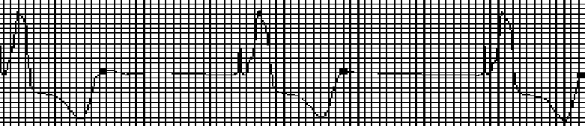
The set rate is 80,but the actual pace rate is 45.note sense marker on T wave, which in appropriately inhibits the pacemaker. Next pace pulse is late which disrupts the timing cycle of the pacemaker.

Failure to Capture:
The most common reason for not obtaining capture is failure to increase the current sufficiently to electrically stimulate the heart.
Capture thresholds vary markedly among individuals and may change over time.
Current should be increased as much as needed for electrical capture.
Safety Precautions:
- Patients should never be left unattended during noninvasive pacing
- Pacing thresholds may change and loss of capture may result
- It is safe to touch the patient and perform procedures such as CPR during pacing
- If a pacing electrode falls off, therapy will be interrupted
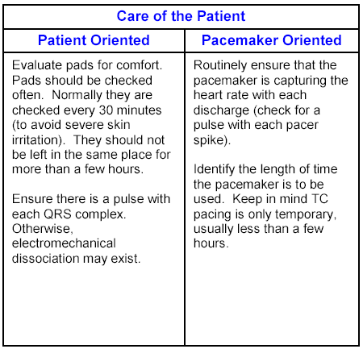

Special Consideration:
CPR
- CPR can be performed with the TCP pads in place.
- The low Joules delivered and the insulation of the flexible TCP pads result in no electrical hazard to the person performing CPR. However, turning the unit off during CPR is advisable.
- In TCPs without an intrinsic defibrillator, separate leads need to be applied.
- The external pacemaker should be turned off or to monitoring mode when defibrillating or cardioverting a patient.
- Defibrillator paddles should be placed at least 2-3 cm away from TCP stimulation pads to prevent arcing of current. Pacing pads should be placed in the anterior/posterior position.
- Remember that TCPs are only a temporizing measure. If a permanent pacemaker is indicated, arrangements for placement should be made.

